**Alternative Final**

**Example:**

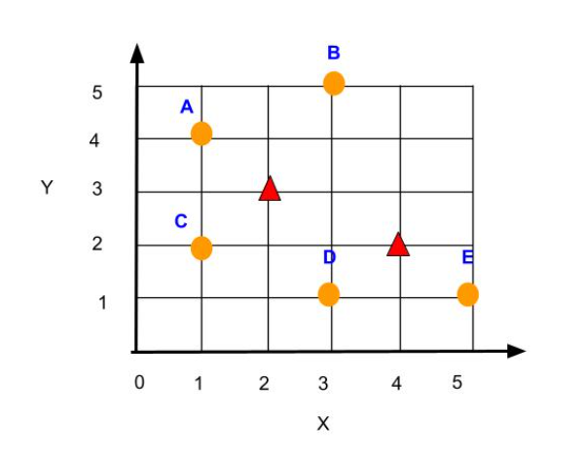

In the above plot, orange dots are data points, red triangles are random cluster centers at initialization. After one iteration of K-means (K=2)

1. What are the coordinates of the new cluster centers? Your answer will be in the following format (x,y)  e.g. (1,4) and (2,3), show your steps
2. In the new clusters identified, state which data points belong to the which clusters, for example, your answer will be in the format: (B, D) and (A, C, E), this means that B, D belong to the same cluster and A,C,E belong to a different cluster.  Show your steps

